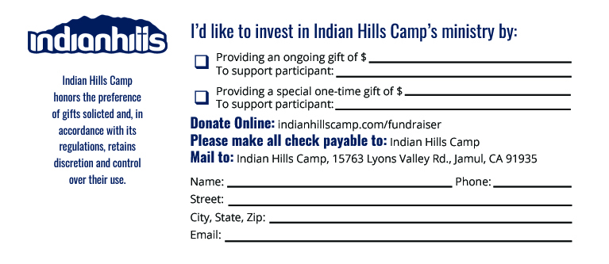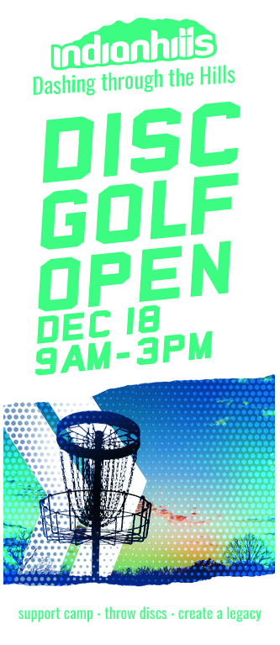 ­­­­­

**Customizable Area #3**

**INSTRUCTIONS:**

Please use this flier outline as a tool to help you raise your pledge. Anything in **RED** requires your attention and should be changed or removed before printing. Feel free to make this flier your own (**keeping pics the same**).

**Directions for Printing:**

1. Customize the 3 areas (Including this one) to desired content.
2. Adjust your font size – Make all your words fit into ALL THREE PANES. Size 14 font is suggested. It is not recommended to use a font size smaller than 11.
3. Select “***Print On Both Sides – Flip Pages On Short Edge***” or select “**Two-Sided Printing**” and select, “***Short Edge Printing****.*” to print properly.
4. Print in color for best results.
5. Fold as a Tri-Fold Brochure.

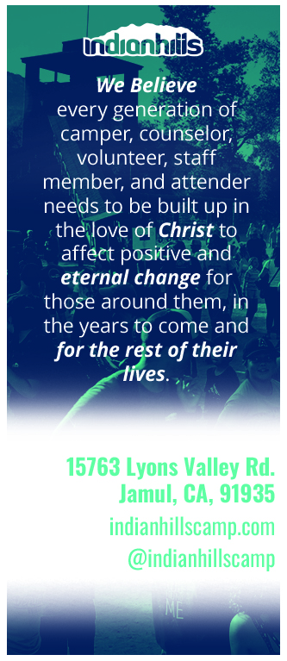

**Customizable Area #2**

I have a fundraising pledge of _$$$ , so that __COPY / PASTE CONTENT, FOR MORE SPECIFIC PARTS OF THE MINISTRY YOU’RE SUPPORTINGEXAMPLE: “THE NEXT GENERATION OF KIDS CAN FIND JESUS AT CAMP LIKE I DID.”

Would you pray for me and for my family in our fundraising, since we are in this together? Would you consider a gift of $50, $100 or even $500 for this cause?

After the event is complete, I will be sharing testimonies with you. Thank you for your friendship and for taking the time to consider my request. You can find out more information at IndianHillsCamp.com. You can donate securely online at **indianhillscamp.com/fundraising** or by check (info on the back).

More room on “Customizable Area 3”

**Customizable Area #1**

Hello Friends!

I, __NAME__ , am taking part in Indian Hills Camp’s Dashing Through the Hills: Disc Golf Open! It’s going to be an awesome event I’m excited to be a part of. I’m a part of an awesome team called __YOUR TEAM NAME__ and I plan on joining my other fundraising champions to reach our team goal of __FUNDRAISING $$$ GOAL__ .

Indian Hills Camp is hosting the Disc Golf Open as a way to raise funds and keep camp going. Since 1960, they’ve worked to impact the lives of campers and staff alike, reaching kids for Jesus through camping.

I have decided to fundraise because __INSERT **COUNTRY & REASON FOR FUNDRAISING** AND/OR HOW CAMP HAS IMPACTED YOUR LIFE FOR THE BETTER. YOU CAN ALSO FIND EXAMPLES ON OUR FUNDRAISING TOOLKIT PAGE ON OUR WEBSITE.